Exp1:-
Title of the program:-
Write a program to extract integer character from a string. If no integer is present then print “No integer”.
Program instruction:-
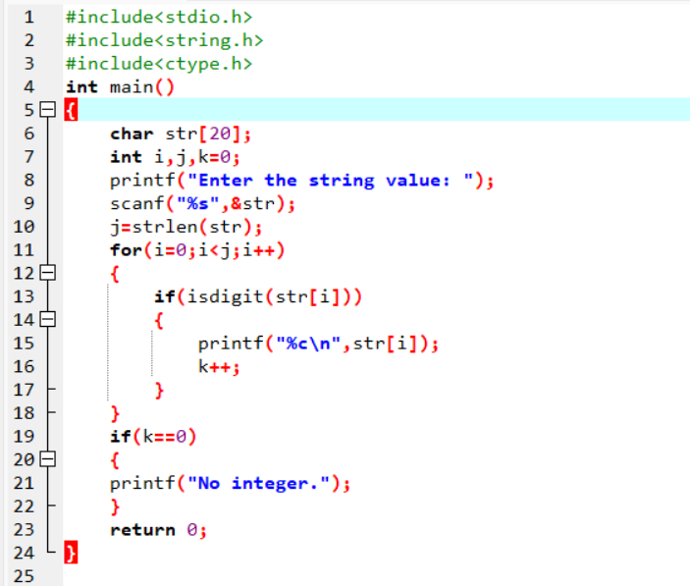
Output:-

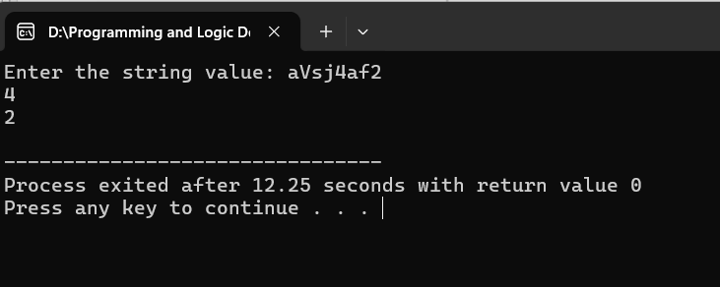

Exp2:-
Title of the program:-
Write a program to convert lower case string to upper case & vice versa.
Program instruction:-
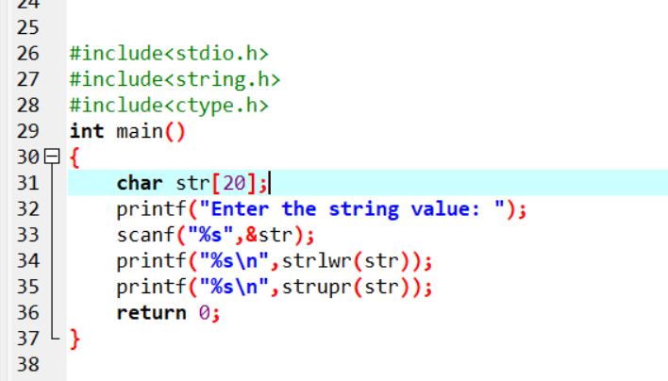
Output:-

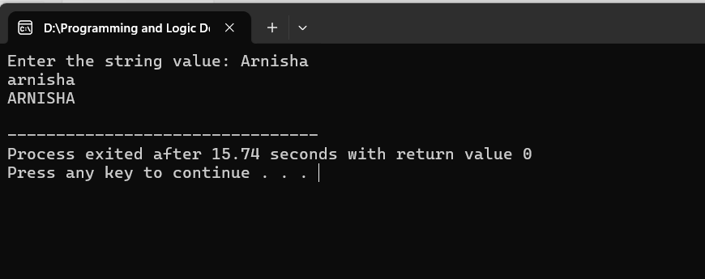
Exp3:-
Title of the program:-
Write a program to take user name & password from user and compare with pre-assigned values.
If matched print “Login successful” else print “Invalid login”.
Program instruction:-
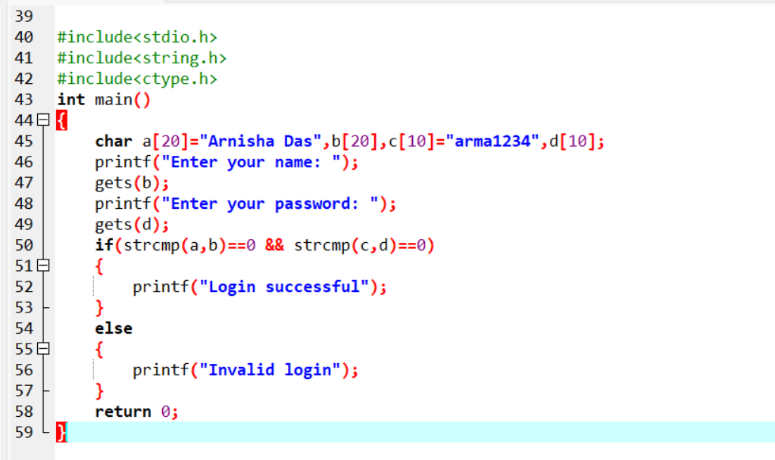
Output:-
